**MEETING: 3 8/8/20**

**MEMBERS PRESENT:**

Danny

Carl

Minjin

Chatchapat

**MEETING CALLED TO ORDER:**

1pm - 1:55pm

**REVIEW:**

The outcome of last week’s progress mark was discussed.

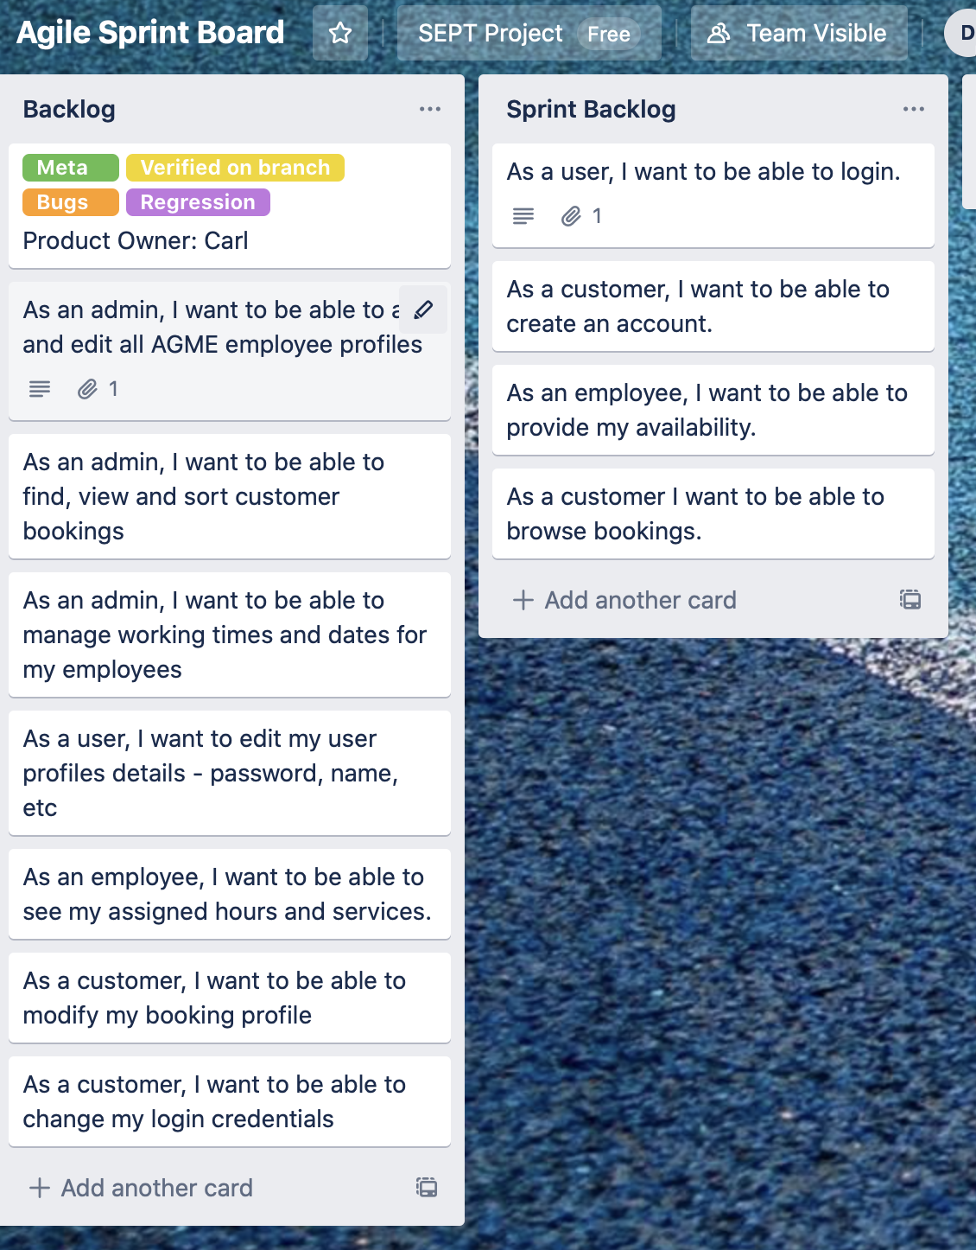

**INFORMATION/DECISIONS**

1. We will make an attempt with microservice architecture

2. Write acceptance tests for each user story

3. Confirmed the users stories we will start planning for.

**ACTION ITEMS**

1. Email Lawrence on what is actually required for the next milestone (acceptance test for all the user stories written ? will they be checking github ?).
2. Have sprint backlogs ready to go.
3. Plan out how we will implement a microservice architecture for this application.
4. All members will be writing an acceptance test for each of their user stories.

**NEXT MEETING**

**Thursday 13/8/20**